BIT/ 2024/73820
DOCUMENTATION
Week 1:
Installation and configuration of IDE(s): Android Studio & flutter
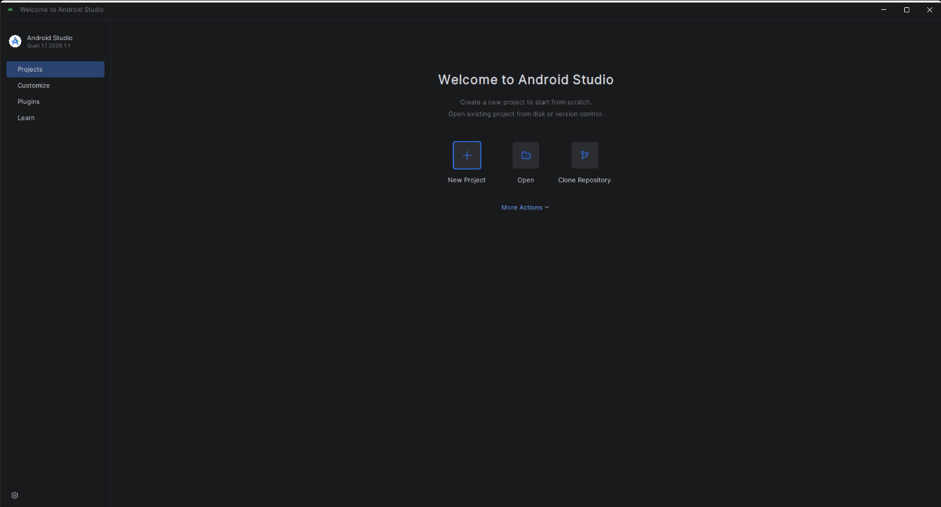
Flutter doctor output
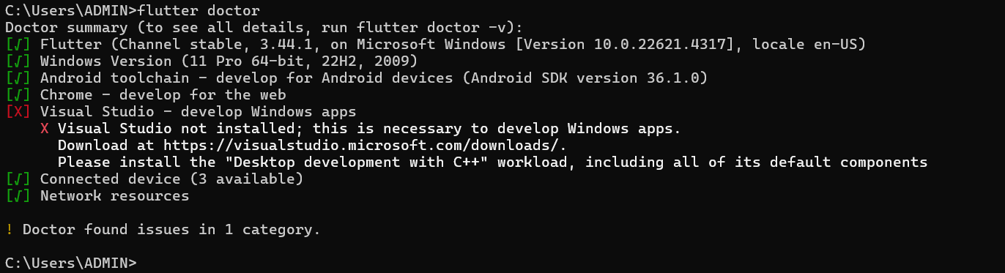
(Visual studio indicates an error because the main choice of coding mobile applications environment was Android studio hence there was no need to install visual studio)

Practical Assignment: Hello World output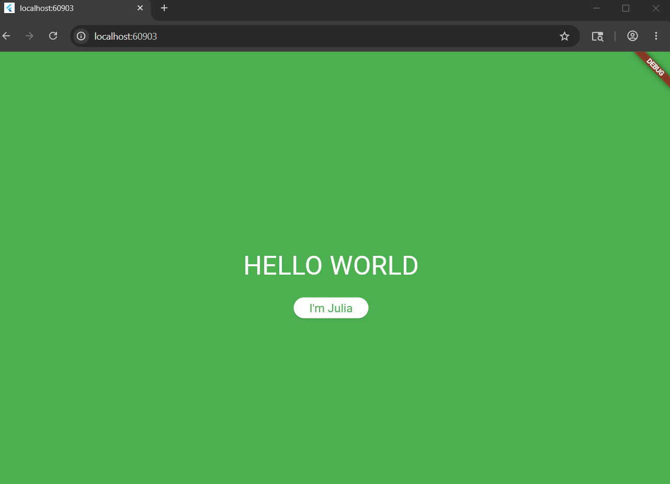

Assignment: Build a Flutter app and alter its widgets and theme (Altered Hello world app)
Output after changes:

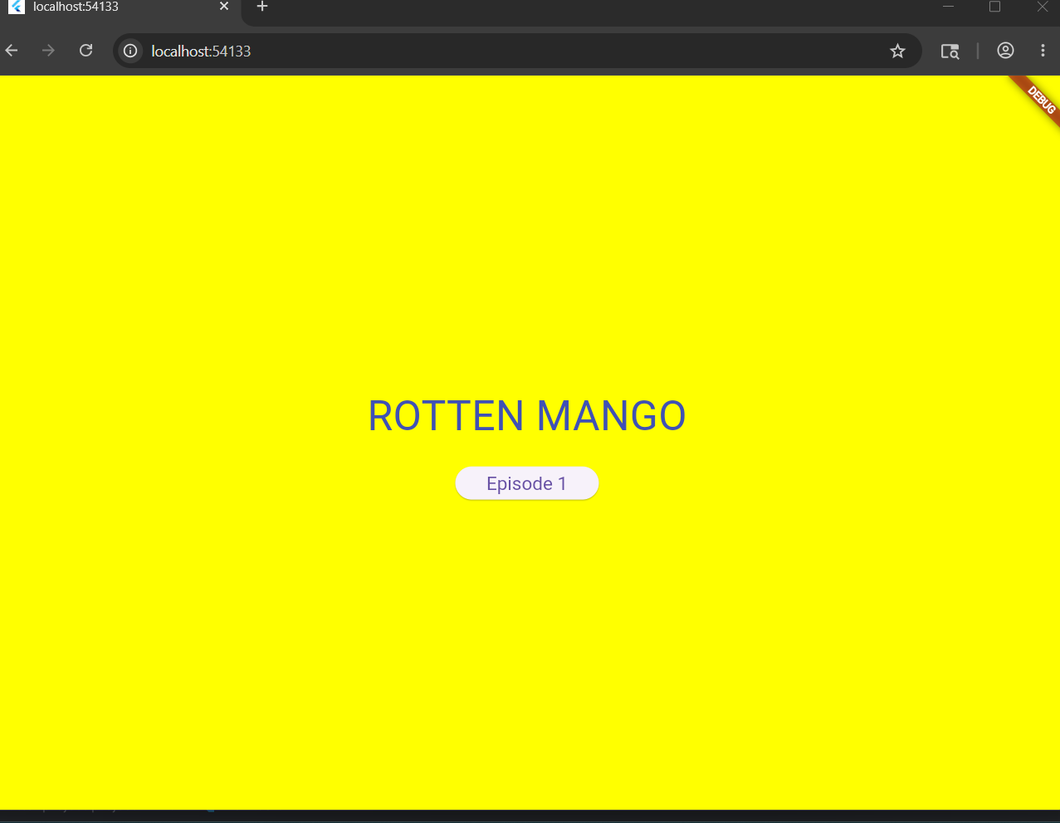
Week 2:
Mini Management app for students
Log in Page- allows users to input credentials to access records
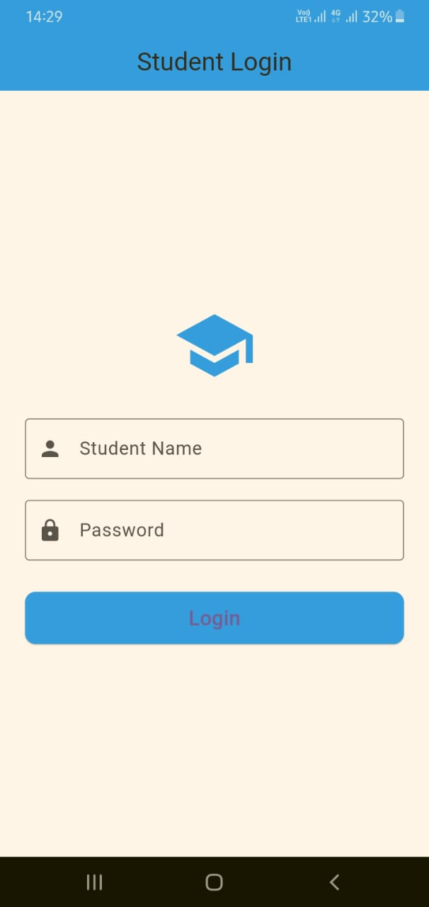

Record editing page- allows the user to manipulate the records they intent to store
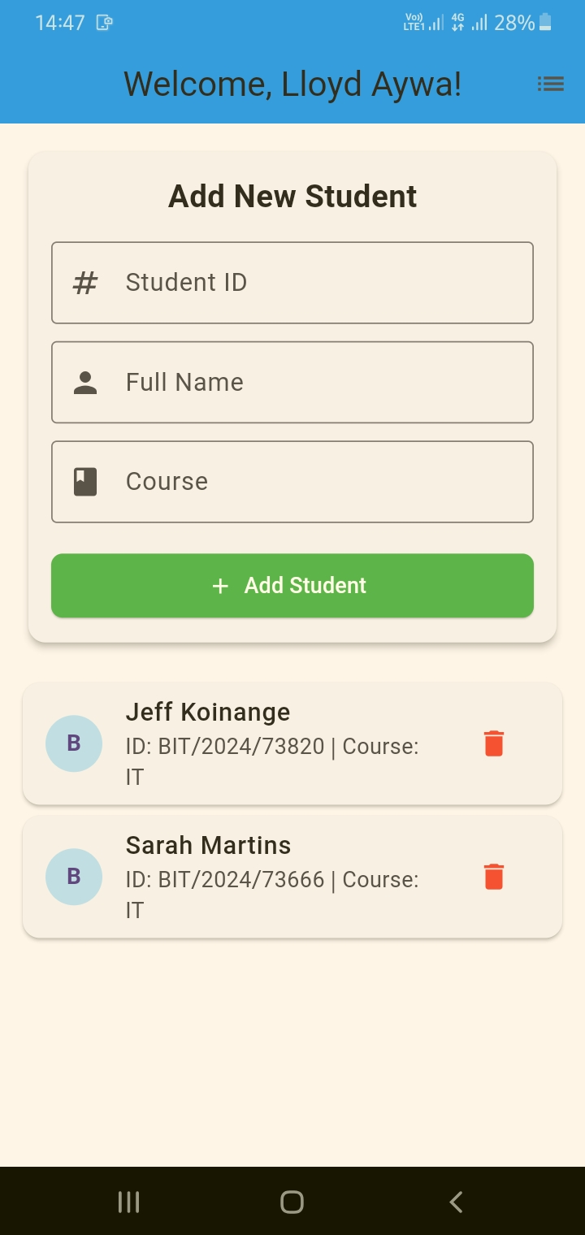

Record list page- it showcases a list of student records saved in the app
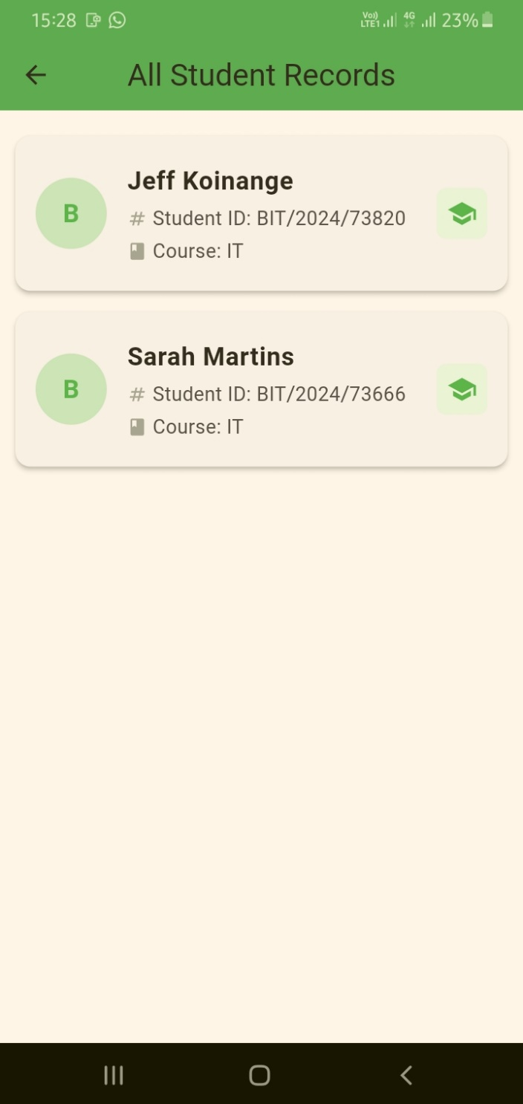

Week 3
App design and output
The following are the designs and output of the Shredded squad fitness app that records fitness progress and gives an option for exercises that should be done to hit fitness goal and weight.
Designs via figma:
The progress and statistics page – tracks users progress
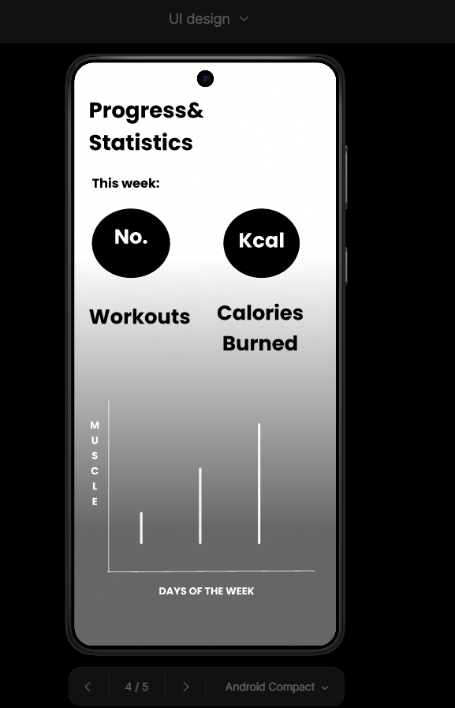
Profile page- allows user to view and edit their profile
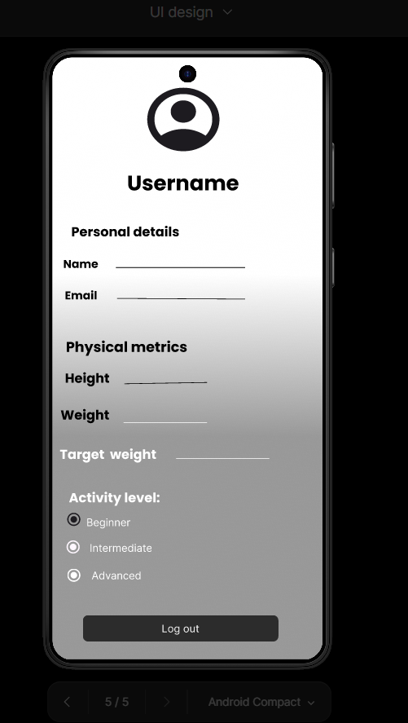
Dashboard page- it is a central page displaying app’s functionality
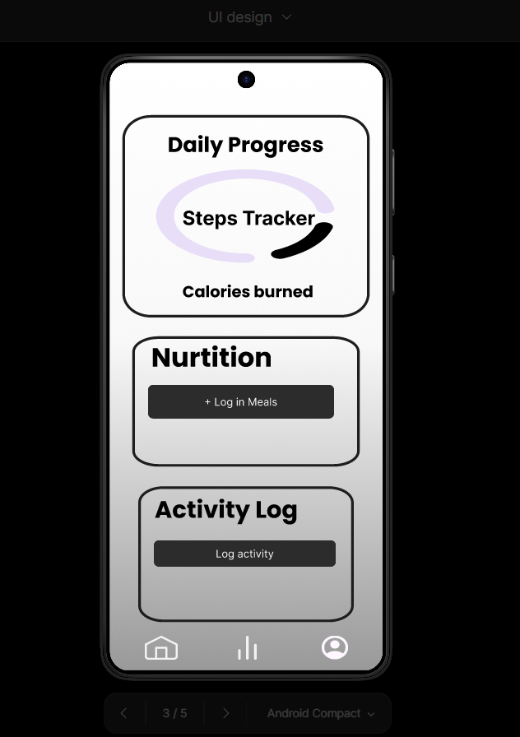

Login page- where credentials are input to access app account
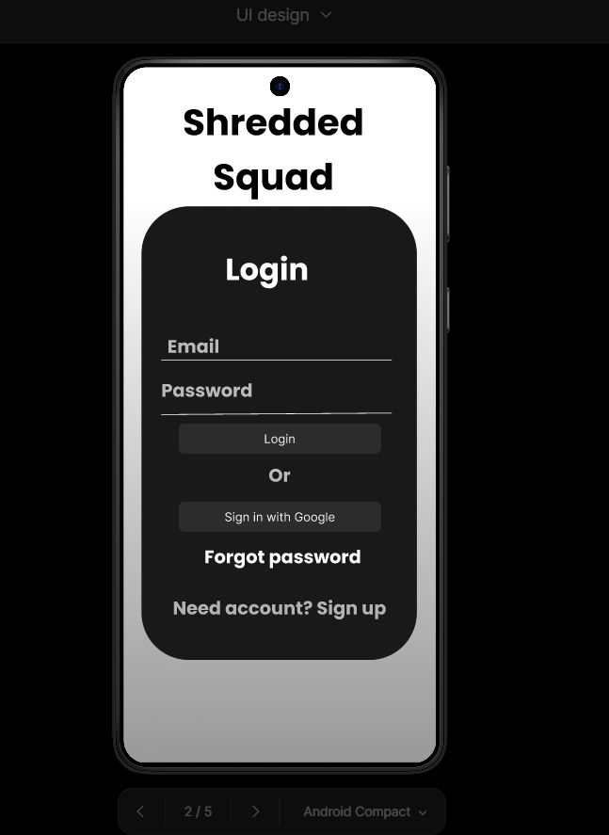
Introduction page- displays the app’s logo as an introduction to the app
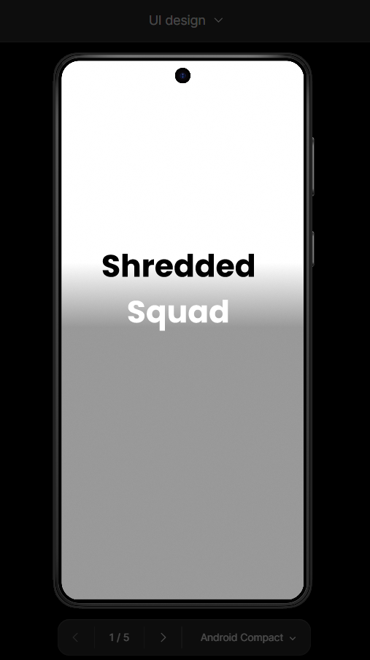

Output after code implementation:
Introduction page- showcases the app’s logo as an introduction of the app

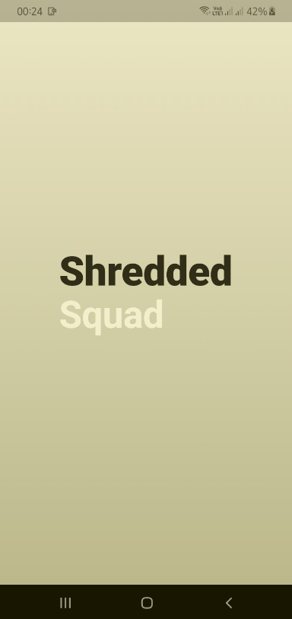
Login page- a page where the user enters their credentials to access the app’s functionalities
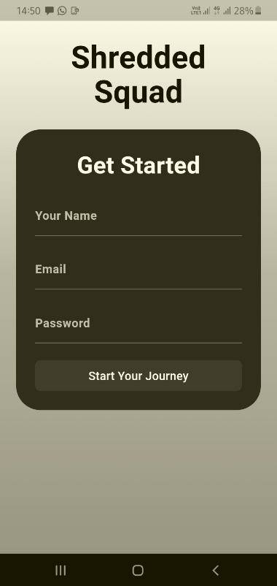
Dashboard/home page- display user name and profile, showing all the capabilities of the app
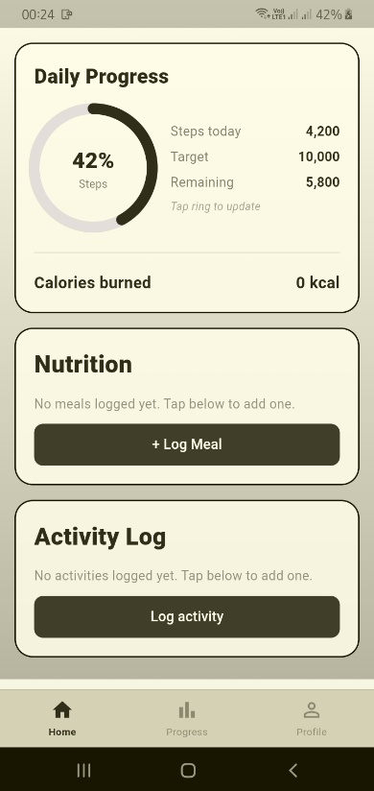

Statistics page- allows the user to track their progress over time through the graph bar and the number of calories they burn through the course of the week
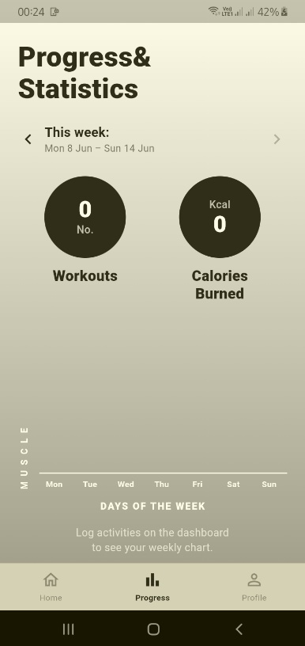
Profile page – allows users to edit their profile by logging their weight , uploading their profile photos and logging out of the app
